**Practical No: 5**

**Design the UI using any active elements of Interface Design**

Active elements in UI design refer to components and features that engage users and enable interactive experiences. These elements are crucial for creating dynamic and user-friendly interfaces. Here are some key active elements in UI design:

1. **Buttons:**

Buttons are interactive elements that initiate actions when clicked. Hover, pressed, and disabled states provide visual feedback to users.

1. **Links:**

Links allow users to navigate between different pages or sections. Visual changes when hovering over links enhance interactivity.

1. **Dropdowns and Selectors:**

Dropdowns allow users to select from a list of options. Changing content dynamically based on user selections.

1. **Checkboxes and Radio Buttons:**

Users can make choices or select options using checkboxes and radio buttons. Organizing options in logical groups for clarity.

1. **Toggle Switches:**

Toggle switches allow users to quickly switch between two states. Clear visual cues indicate the current state.

1. **Menus:**

Menus provide a list of options for users to choose from. Hierarchical menus allow for organized content.

1. **Tabs:**

Tabs enable users to switch between different sections or views. Highlighting the active tab for clarity.

1. **Interactive Charts and Graphs:**

Users can interact with charts to explore data in more detail. Enabling users to zoom in or pan across charts for a closer view.

Step 1: Open Figma with login with your account.

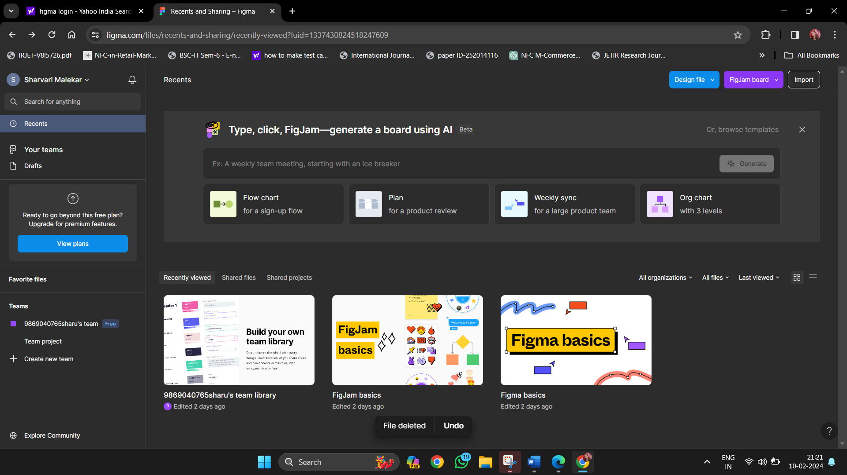

Step 2: Open Figma: Launch Figma and create a new project.

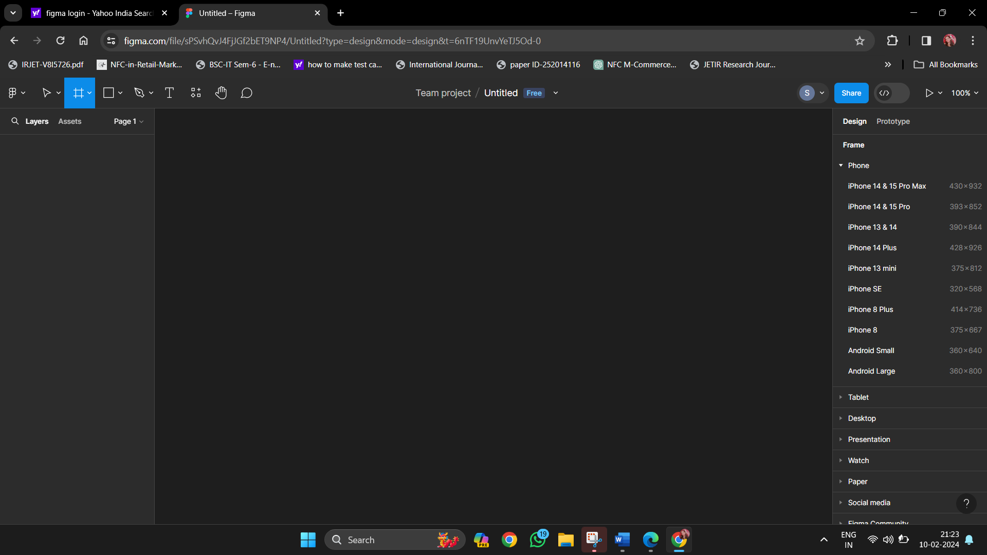

Step 3: Create a new frame to represent your design canvas.

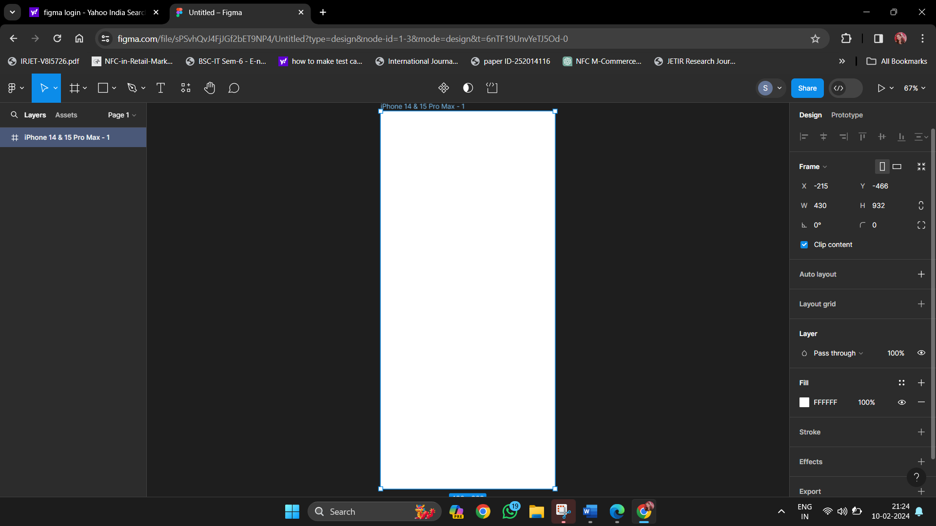

Step 4: Use Images and Text instead of basic shapes and line.

